Examples of what children should be able to do, in relation to each (boxed) Programme of Study statement
Pupils should be taught to recognise and name common 2-D and 3-D shapes, including [for example] rectangles (including squares), circles, triangles, cuboids (including cubes), pyramids and spheres.
Give each child this shape
Child A
Child B
Child C
Child D
Look at the Shape I have given you. Tell me one thing about the shape.
Hand each child this shape.
Child A:cylinder
Child B:triangular prism
Child C:cone
Child D:cube
Look at the shape I have given you. Tell me one thing about the shape.

(Give each child two different shapes.)
Tell me something that is the same about the two shapes.
Now tell me something that is different about the two shapes.

One shape has 2 long sides and 2 short sides.
Tick (✔) it.
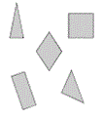
Fred draws round the bottom of a cone.
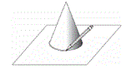
Tick (✔) the shape that Fred draws.
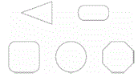

Non-Statutory Guidance
Pupils handle common 2-D and 3-D shapes, naming these and related everyday objects fluently. They recognise these shapes in different orientations and sizes, and know that rectangles, triangles, cuboids and pyramids are not always similar to each other.

