Examples of what children should be able to do, in relation to each (boxed) Programme of Study statement
order and arrange combinations of mathematical objects in patterns
- Describe the patterns in sequences and predict what comes next in the sequence and continue the pattern.
use mathematical vocabulary to describe position, direction and movement including distinguishing between rotation as a turn and in terms of right angles for quarter, half and three- quarter turns (clockwise and anti-clockwise), and movement in a straight line
- Recognise whole, half and quarter turns. They describe turns and give and follow instructions to turn. For example, they give instructions to a friend to follow a route around the playground. They make and draw half and quarter turns from the same starting point using, for example, two geostrips.
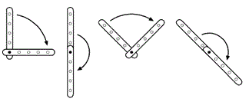
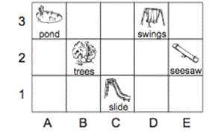
Use the grid to help you complete this table.
trees | B2
slide
seesaw
 | A3
Watch me as I rotate (turn) this picture of a clown.
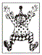
(Rotate the clown smoothly and continuously through a full turn, keeping it facing the children a t all times.)
Which of the pictures shows what the clown will look like if I rotate (turn) my picture a half turn?
Tick the picture
(Do not rotate your picture this time)
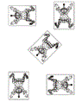

Non-Statutory Guidance
Pupils should work with patterns of shapes, including those in different orientations.
Pupils use the concept and language of angles to describe ‘turn’ by applying rotations, including in practical contexts (for example, pupils themselves moving in turns, giving instructions to other pupils to do so, and programming robots using instructions given in right angles).

