Examples of what children should be able to do, in relation to each (boxed) Programme of Study statement
interpret and construct pie charts and line graphs and use these to solve problems
This graph shows the number of people living in a town.
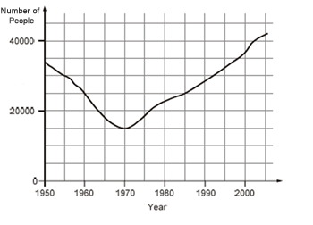
How many people lived in the town in 1985?
In which year was the number of people the same as in 1950?
Find the year when the number of people first went below 20 000.
KS2 2008 Paper A level 5
Class 6 did a survey of the number of trees in a country park. This pie chart shows their results.
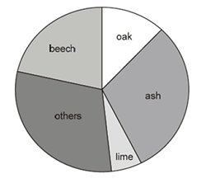
Estimate the fraction of trees in the survey that are oak trees. The children counted 60 ash trees. Use the pie chart to estimate the number of beech trees they counted.
KS2 2006 Paper A level 5
calculate and interpret the mean as an average
From a simple database, children should be able to find the most common score (mode) as well as the mean score for each test.
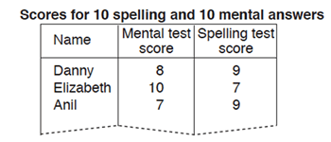
Children should be able to choose their own sets of data to match given criteria, e.g. find a set of five numbers that have a mean of 5 and a range of 7.

Non-Statutory Guidance
Pupils connect their work on angles, fractions and percentages to the interpretation of pie charts.
Pupils both encounter and draw graphs relating two variables, arising from their own enquiry and in other subjects.
They should connect conversion from kilometres to miles in measurement to its graphical representation.
Pupils know when it is appropriate to find the mean of a data set.

