Examples of what children should be able to do, in relation to each (boxed) Programme of Study statement
recognise and show, using diagrams, families of common equivalent fractions
Recognise that five tenths (⁵⁄₁₀) or one half is shaded.
Recognise that two eighths (²⁄₈) or one quarter (¼) of the set of buttons is ringed
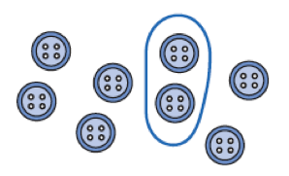
Recognise that one whole is equivalent to two halves, three thirds, four quarters… For example, build a fraction ‘wall’ using a computer program and then estimate parts.
Recognise patterns in equivalent patterns, such as:
½ = ²⁄₄ = ³⁄₆ = ⁴⁄₈ = ⁵⁄₁₀ = ⁶⁄₁₂ = ⁷⁄₁₄ And similar patterns for ⅓, ¼, ⅕, ⅙, ¹⁄₁₀.

Here is a square.
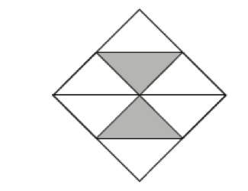
What fraction of the square is shaded?
Here are five diagrams. Look at each one.
Put a tick (✔︎) on the diagram is exactly ½ of it is shaded. Put a cross (✗) if it us not.
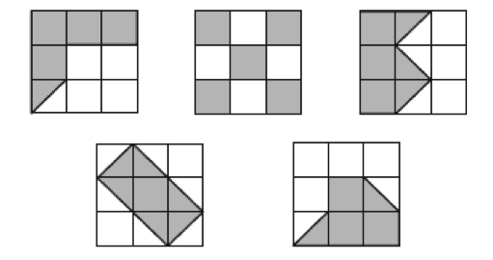

count up and down in hundredths; recognise that hundredths arise when dividing an object by a hundred and dividing tenths by ten
Respond to questions such as:
What does the digit 6 in 3.64 represent? The 4? What is the 4 worth in the number 7.45? The 5?
Write the decimal fraction equivalent to:
two tenths and five hundredths; twenty-nine hundredths; fifteen and nine hundredths.
Continue the count 1.91, 1.92, 1.93, 1.94 ...
Suggest a decimal fraction between 4.1 and 4.2
Know how many 10 pence pieces equal a pound, how many 1 pence pieces equal a pound, how many centimetres make a metre.

solve problems involving increasingly harder fractions to calculate quantities, and fractions to divide quantities, including non-unit fractions where the answer is a whole number
What is one-fifth of twenty-five?
Write the missing number to make this correct.
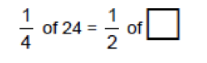
Mary has 20 pet stickers to go on this page.
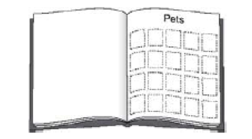
¼ of them are dog stickers. ½ of them are cat stickers. The rest are rabbit stickers. How many rabbit stickers does she have?
Match each box to the correct number. One has been done for you.
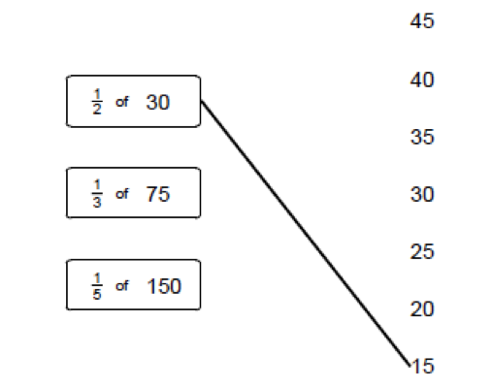
add and subtract fractions with the same denominator
For example:
½ + ½, ¼ + ¾, ⅜ + ⅝, ⅗ + ⅘ + ⅕, ⁷⁄₁₀ + ³⁄₁₀ + ⁵⁄₁₀ + ⁸⁄₁₀, ¾ - ⅓, ⁶⁄₇- ⁴⁄₇, ⁹⁄₁₀ + ⁴⁄₁₀, – ³⁄₁₀

recognise and write decimal equivalents of any number of tenths or hundredths
Recognise that, for example:
0.07 is equivalent to ⁷⁄₁₀₀ 6.35 is equivalent to 6 ³⁵⁄₁₀₀
Particularly in the contexts of money and measurement
Respond to questions such as:
Which of these decimals is equal to ¹⁹⁄₁₀₀? 1.9 10.19 0.19 19.1 Write each of these as a decimal fraction: ²⁷⁄₁₀₀ ³⁄₁₀₀ 2 ³³⁄₁₀₀
recognise and write decimal equivalents to ¼; ½; ¾
Know that, for example
0.5 is equivalent to ½, 0.25 is equivalent to ¼, 0.75 is equivalent to ¾, 0.1 is equivalent to ¹⁄₁₀
Particularly in the context of money and measurement.

find the effect of dividing a one- or two-digit number by 10 and 100, identifying the value of the digits in the answer as units, tenths and hundredths
Understand that:
When you divide a number by ¹⁄₁₀₀, the digits move one/two places to the right.
Write a two-digit number on the board. Keep dividing by 10 and record the answer. Describe the pattern.
26
2.6
0.26
0.026
Respond to oral or written questions such as:
How many times larger is 2600 than 26?
How many £1 notes are in £120, £1200?
Divide three hundred and ninety by ten.
Write in the missing number

round decimals with one decimal place to the nearest whole number
Round these to the nearest whole number. For example:
9.7, 25.6, 148.3
Round these lengths to the nearest metre:
1.5m, 6.7m, 4.1m, 8.9m
Round these costs to the nearest £:
£3.27, £12.60, £14.05, £6.50

compare numbers with the same number of decimal places up to two decimal places
Place these decimals on a line from 0 to 2:
0.3, 0.1, 0.9, 0.5, 1.2, 1.9
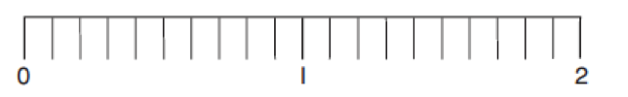
Which is lighter: 3.5kg or 5.5kg? 3.72kg or 3.27kg? Which is less: £4.50 or £4.05?
Put in order, largest/smallest first:
6.2, 5.7, 4.5, 7.6, 5.2, 99, 1.99, 1.2, 2.1
Convert pounds to pence and vice versa. For example: Write 578p in £.
How many pence is £5.98, £5.60, £7.06, £4.00? Write the total of ten £1 coins and seven 1p coins (£10.07)
Write centimetres in metres. For example, write: 125 cm in metres (1.25 metres)
solve simple measure and money problems involving fractions and decimals to two decimal places.
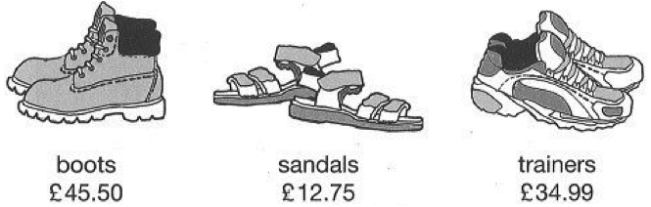
These are the prices in a shoe shop
How much more do the boots cost than the trainers? Rosie buys a pair of trainers and a pair of sandals. How much change does she get from £50?
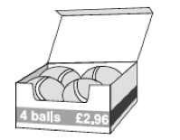A box of four balls costs £2.96. How much does each ball cost? Dean and Alex buy 3 boxes of balls between them. Dean pays £4.50. How much must Alex pay? KS2 Paper B level 3
A full bucket holds 5½ litres. A full jug holds ½ a litre. How many jugs full of water will fill the bucket?
Harry spent one quarter of his savings on a book. What did the book cost if he saved: £8…£10…£2.40…?
Gran gave me £8 of my £10 birthday money. What fraction of my birthday money did Gran give me?
Max jumped 2.25 metres on his second try at the long jump.
This was 75 centimetres longer than on his first try.
How far in metres did he jump on his first try?

Non-Statutory Guidance
Pupils should connect hundredths to tenths and place value and decimal measure.
They extend the use of the number line to connect fractions, numbers and measures.
Pupils understand the relation between non-unit fractions and multiplication and division of quantities, with particular emphasis on tenths and hundredths.
Pupils make connections between fractions of a length, of a shape and as a representation of one whole or set of quantities. Pupils use factors and multiples to recognise equivalent fractions and simplify where appropriate(for example,⁶⁄₉ = ²⁄₃ or ¹⁄₄ = ²⁄₈).
Pupils continue to practise adding and subtracting fractions with the same denominator, to become fluent through a variety of increasingly complex problems beyond one whole.
Pupils are taught throughout that decimals and fractions are different ways of expressing numbers and proportions.
Pupils’ understanding of the number system and decimal place value is extended at this stage to tenths and then hundredths. This includes relating the decimal notation to division of whole number by 10 and later 100.
They practise counting using simple fractions and decimals, both forwards and backwards.
Pupils learn decimal notation and the language associated with it, including in the context of measurements. They make comparisons and order decimal amounts and quantities that are expressed to the same number of decimal places. They should be able to represent numbers with one or two decimal places in several ways, such as on number lines

