Examples of what children should be able to do, in relation to each (boxed) Programme of Study statement
compare and classify geometric shapes, including quadrilaterals and triangles, based on their properties and sizes
Pupils should be able to complete this sentence:
All equilateral triangles have …
identify acute and obtuse angles and compare and order angles up to two right angles by size
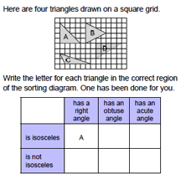
identify lines of symmetry in 2-D shapes presented in different orientations
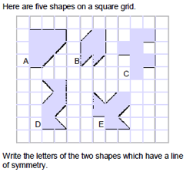

complete a simple symmetric figure with respect to a specific line of symmetry
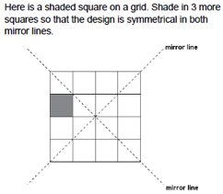

Non-Statutory Guidance
Pupils continue to classify shapes using geometrical properties, extending to classifying different triangles (for example, isosceles, equilateral, scalene) and quadrilaterals (for example, parallelogram, rhombus, trapezium). Pupils compare and order angles in preparation for using a protractor and compare lengths and angles to decide if a polygon is regular or irregular.
Pupils draw symmetric patterns using a variety of media to become familiar with different orientations of lines of symmetry; and recognise line symmetry in a variety of diagrams, including where the line of symmetry does not dissect the original shape.

