Examples of what children should be able to do, in relation to each (boxed) Programme of Study statement
describe positions on the full coordinate grid (all four quadrants)
Children should be able to answer questions such as;
The two shaded squares below are the same size.
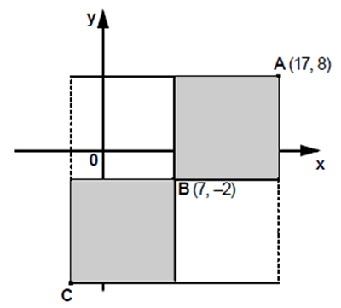
A is the point (17,8). B is the point (7,-2).
What are the co-ordinates of the point C?
draw and translate simple shapes on the coordinate plane, and reflect them in the axes
Children should be able to draw a shape with corners at given vertices, and describe the properties of the shape. Can they create the same shape where all of the coordinates will be positive? Negative?
They should be able to sketch the reflection of a simple shape in two mirror lines at right angles and find the coordinates of selected points.

Non-Statutory Guidance
Pupils draw and label a pair of axes in all four quadrants with equal scaling. This extends their knowledge of one quadrant to all four quadrants, including the use of negative numbers.
Pupils draw and label rectangles (including squares), parallelograms and rhombuses, specified by coordinates in the four quadrants, predicting missing coordinates using the properties of shapes. These might be expressed algebraically for example, translating vertex (a, b) to (a - 2, b + 3); (a, b) and (a + d, b + d) being opposite vertices of a square of side d.

