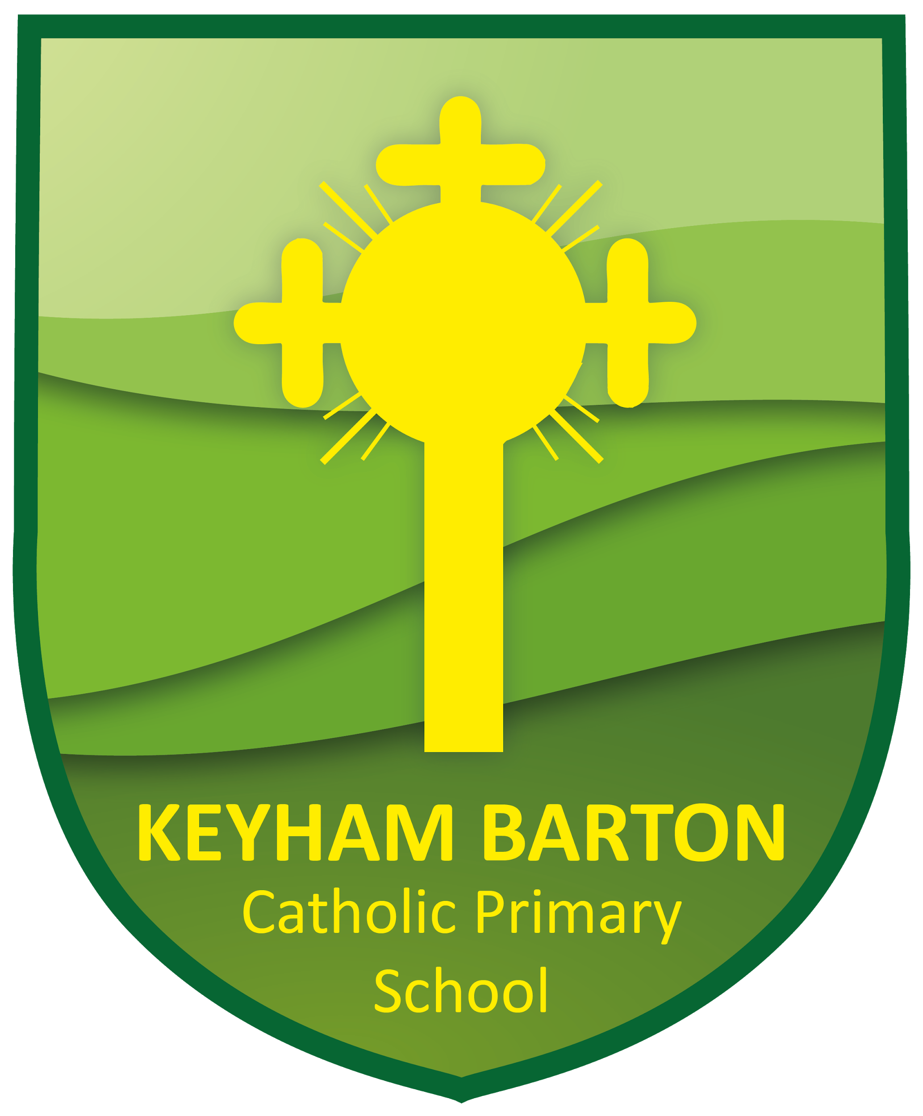
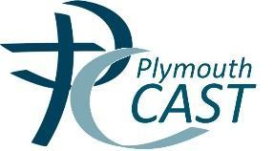
Plymouth CAST
Multi Academy Trust

Summary of Governors meetings 2019-20

September 2019
- Governors re-elected Alaine Cocker as the chair of the Keyham Barton Local Governing Body. Vanessa Cload was elected as co-vice-chair and the role of vice-chair was held over as a special request was to be submitted to the Bishop for a non-foundation before to take on that role.
- Governors was allocated to specific lead roles as directed by CAST.
- Governors were updated on the School Improvement Plan and the School Self Evaluation.
- Governors discussed the Statutory Consultation School Attendance Penalty Notice Code of Conduct
- An update was provided regarding the Keyham Barton Pupil Premium Strategy statement 2019-20 which explained how pupil premium funds were spent.
- The chair relayed the points raised at a recent parish meeting regarding the planned church conversion.
- Various CAST Trust Board policies were acknowledged

December 2019
- Governors were presented to by the deputy head regarding the preparation for a Section 48 School inspection which would focus on monitoring, assessing and raising attainment in RE and evaluating then improving Catholic Life and Collective Worship.
- The headteacher confirmed that there were no recordings of staff Pecuniary Interests, Whistleblowing actions or Gifts and Hospitality received by any staff.
- A governor had resigned and there were currently 2 staff governors’ vacancies.
- Governors received an update on the School Improvement Plan.
- Governors were advised that the progress data at the school was positive however there had been a dip in whole school attendance in the last year. Action was being taken to address this.
- Governors were updated on the marketing strategy CAST schools and on catholic life at Keyham Barton
- An offer was discussed regarding opening the school to the local community for Christmas dinner.

February 2020
- Governors welcomed 2 new staff governors to the Local Governing Body.
- Governors noted the resignation of foundation governor Anne-Marie Sowden.
- The headteacher shared a detailed report updating governors on future roll numbers, marketing and staffing, personal development, leadership and management and financial viability and planning
- Governors discussed the financial management and resources for the school.
- Governor's visits at the school were shared with the governing body.
- The latest trust policies were acknowledged by the governing body.

May 2020
- Governors noted the resignation of a co-opted governor, election of a new vice-chair and the renewal of the governors 4 year term.
- The headteacher updated governors on the current arrangements in school, homeschooling, staffing and activities being completed.
- Governors were updated on any safeguarding issues and the plans for the school moving forwards.

