Examples of what children should be able to do, in relation to each (boxed) Programme of Study statement
choose and use appropriate standard units to estimate and measure length/height in any direction (m/cm); mass (kg/g); temperature (°C); capacity (litres/ml) to the nearest appropriate unit, using rulers, scales, thermometers and measuring vessels
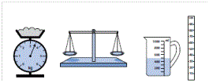
- Suggest sensible units you might use to measure: the height of your table; how much water is in a cup; the weight of my reading book; how long it takes me to wash my hands.
- Choose a piece of equipment to help you measure: the weight of your shoe; how long the classroom is; how long this lesson lasts; how much water a cup holds.
- How long is this line? Now draw a line 2 cm longer than this one.
How much water is in this measuring jug?
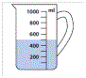
- Find an object in the classroom that you think is about 10 cm long.
About how heavy do you think your pencil case is?
- If I programme my floor turtle to go forward three metres is there enough room in the classroom? How could you measure to find out?
compare and order lengths, mass, volume/capacity and record the results using >, < and =
- Megan and Jack are growing beans. Megan’s plant is 25 cm tall. Jack’s is 38 cm tall. Whose plant is the taller? By how much? Can you compare them using > or < ?
recognise and use symbols for pounds (£) and pence (p); combine amounts to make a particular value

find different combinations of coins that equal the same amounts of money
- Holly has these coins. 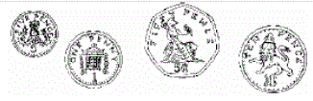
Harry has the same amount of money but has six coins. What are they? Is there only one possible answer?
solve simple problems in a practical context involving addition and subtraction of money of the same unit, including giving change
- Jess has saved 62p. She spends 15p. How much money does she have left? She pays with a 50p piece. How much change does she get?
compare and sequence intervals of time

tell and write the time to five minutes, including quarter past/to the hour and draw the hands on a clock face to show these times.
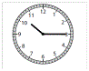
- What time does this clock show?
- Draw a clock showing the time five minutes later.
- Show your school day on clock faces: when do you leave home, have breaks, go back home, etc.?
Know the number of minutes in an hour and the number of hours in a day.

Non-Statutory Guidance
Pupils use standard units of measurement with increasing accuracy, using their knowledge of the number system. They use the appropriate language and record using standard abbreviations.
Comparing measures includes simple multiples such as ‘half as high’; ‘twice as wide’.
They become fluent in telling the time on analogue clocks and recording it.
Pupils become fluent in counting and recognising coins. They read and say amounts of money confidently and use the symbols £ and p accurately, recording pounds and pence separately.

