Examples of what children should be able to do, in relation to each (boxed) Programme of Study statement
count in steps of 2, 3, and 5 from 0, and in tens from any number, forward or backward
- Use their knowledge of counting on from or back to zero in steps of 2, 3, 5 and 10 to answer multiplication and division questions such as 7 × 2 and 40 ÷ 5. They understand that one way to work out 40 ÷ 5, for example, is to find out how many fives make 40. They know that this can be done by counting forwards in fives from zero or backwards in fives from 40.
Write the missing numbers in each of these patterns.
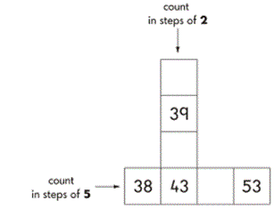
recognise the place value of each digit in a two-digit number (tens, ones)
Look at these numbers.
37 12 45 60 72 27
Which of these numbers is the largest?
Which of these numbers is between 10 and 20?
What is the value of…? (point to digits in the list above

identify, represent and estimate numbers using different representations, including the number line
- Children should be able to represent numbers using equipment such as bundles of ten and single art-straws, 10p and 1p coins and number lines.
Look at the squares of chocolate
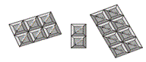
There are 16 squares
Tick(✔) the sum that matches the picture
5+2+9=16
5+6+5=16
6+6+4=16
6+2+8=16
8+3+5=16

compare and order numbers from 0 up to 100; use <, > and = signs
Here are two signs
Use these signs to make these correct
52 ☐ 17
18 ☐ 91
50 ☐ 34
- Children should be able to order a set of two-digit numbers, such as 52, 25, 5, 22, 2, 55. They explain their decisions. They understand and use the < and > symbols; for example, they write a two-digit number to make the statement 56 > ☐ true.

read and write numbers to at least 100 in numerals and in words
- Children should be able to answer questions, such as:
  - What numbers can you make using two of these digits: 3, 6, 0?
  - Write down each number you make. Read those numbers to me. Can you write the largest of the numbers in words?

Use place value and number facts to solve problems

Non-Statutory Guidance
Using materials and a range of representations, pupils practise counting, reading, writing and comparing numbers to at least 100 and solving a variety of related problems to develop fluency. They count in multiples of three to support their later understanding of a third.
As they become more confident with numbers up to 100, pupils are introduced to larger numbers to develop further their recognition of patterns within the number system and represent them in different ways, including spatial representations.
Pupils should partition numbers in different ways (for example, 23 = 20 + 3 and 23 = 10 + 13) to support subtraction. They become fluent and apply their knowledge of numbers to reason with, discuss and solve problems that emphasise the value of each digit in two-digit numbers. They begin to understand zero as a place holder.

