Examples of what children should be able to do, in relation to each (boxed) Programme of Study statement
Pupils should be taught to describe position, direction and movement, including whole, half, quarter and three-quarter turns.
Look at the map. Go to start.
Follow this route from there.
Go to the fourth house on the right.
Draw a ring around it.
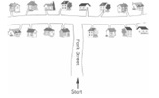
Look at this map
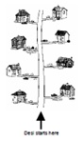
Desi's house is the 2nd on the left. Tick ( ✔) it.

Non-Statutory Guidance
Pupils use the language of position, direction and motion, including: left and right, top, middle and bottom, on top of, in front of, above, between, around, near, close and far, up and down, forwards and backwards, inside and outside. Pupils make whole, half, quarter and three-quarter turns in both directions and connect turning clockwise with movement on a clock face.

