Examples of what children should be able to do, in relation to each (boxed) Programme of Study statement
solve problems involving the calculation and conversion of units of measure, using decimal notation up to three decimal places where appropriate
- Children should be able to draw a flow chart to help someone else convert between mm, cm, m and km.
- They should be able to answer questions such as: approximately how many litres are there in 3 gallons? Give your answer to the nearest litre.

use, read, write and convert between standard units, converting measurements of length, mass, volume and time from a smaller unit of measure to a larger unit, and vice versa, using decimal notation to up to three decimal places
This scale (not actual size) shows length measurements in centimetres and feet.
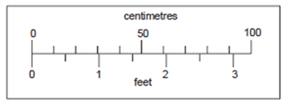
Look at the scale. Estimate the number of centimetres that are equal to 2 ½ feet.
Estimate the difference in centimetres between 50 cm and 1 foot.

convert between miles and kilometres
- Pupils should know the approximate equivalence between commonly used imperial units and metric units:
e.g. 1 litre is approximately 2 pints (more accurately, 1 ¾ pints)
4.5 litres is approximately 1 gallon or 8 pints
1 kilogram is approximately 2 lb (more accurately, 2.2 lb)
30 grams is approximately 1 oz
8 kilometres is approximately 5 miles
- Children should be able to use conversion graphs that show miles/kilometres. They should be able to use it to estimate a distance of 95 miles in kilometres.
recognise that shapes with the same areas can have different perimeters and vice versa
The perimeter of a square is 72 centimetres.
The square is cut in half to make two identical rectangles.
What is the perimeter of one rectangle?

recognise when it is possible to use formulae for area and volume of shapes
Children should be able to calculate the perimeters of compound shapes that can be split into rectangles. For example,
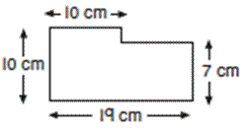

calculate the area of parallelograms and triangles
This is a centimetre grid. Draw 3 more lines to make a parallelogram with an area of 10cm². Use a ruler.
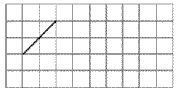

calculate, estimate and compare volume of cubes and cuboids using standard units, including cubic centimetres (cm³) and cubic metres (m³), and extending to other units [for example, mm³ and km³]

Non-Statutory Guidance
Pupils connect conversion (for example, from kilometres to miles) to a graphical representation as preparation for understanding linear/proportional graphs.
They know approximate conversions and are able to tell if an answer is sensible.
Using the number line, pupils use, add and subtract positive and negative integers for measures such as temperature.
They relate the area of rectangles to parallelograms and triangles, for example, by dissection, and calculate their areas, understanding and using the formulae (in words or symbols) to do this.
Pupils could be introduced to compound units for speed, such as miles per hour, and apply their knowledge in science or other subjects as appropriate.

