KEYHAM BARTON CATHOLIC PRIMARY SCHOOL

MARKING and FEEDBACK POLICY
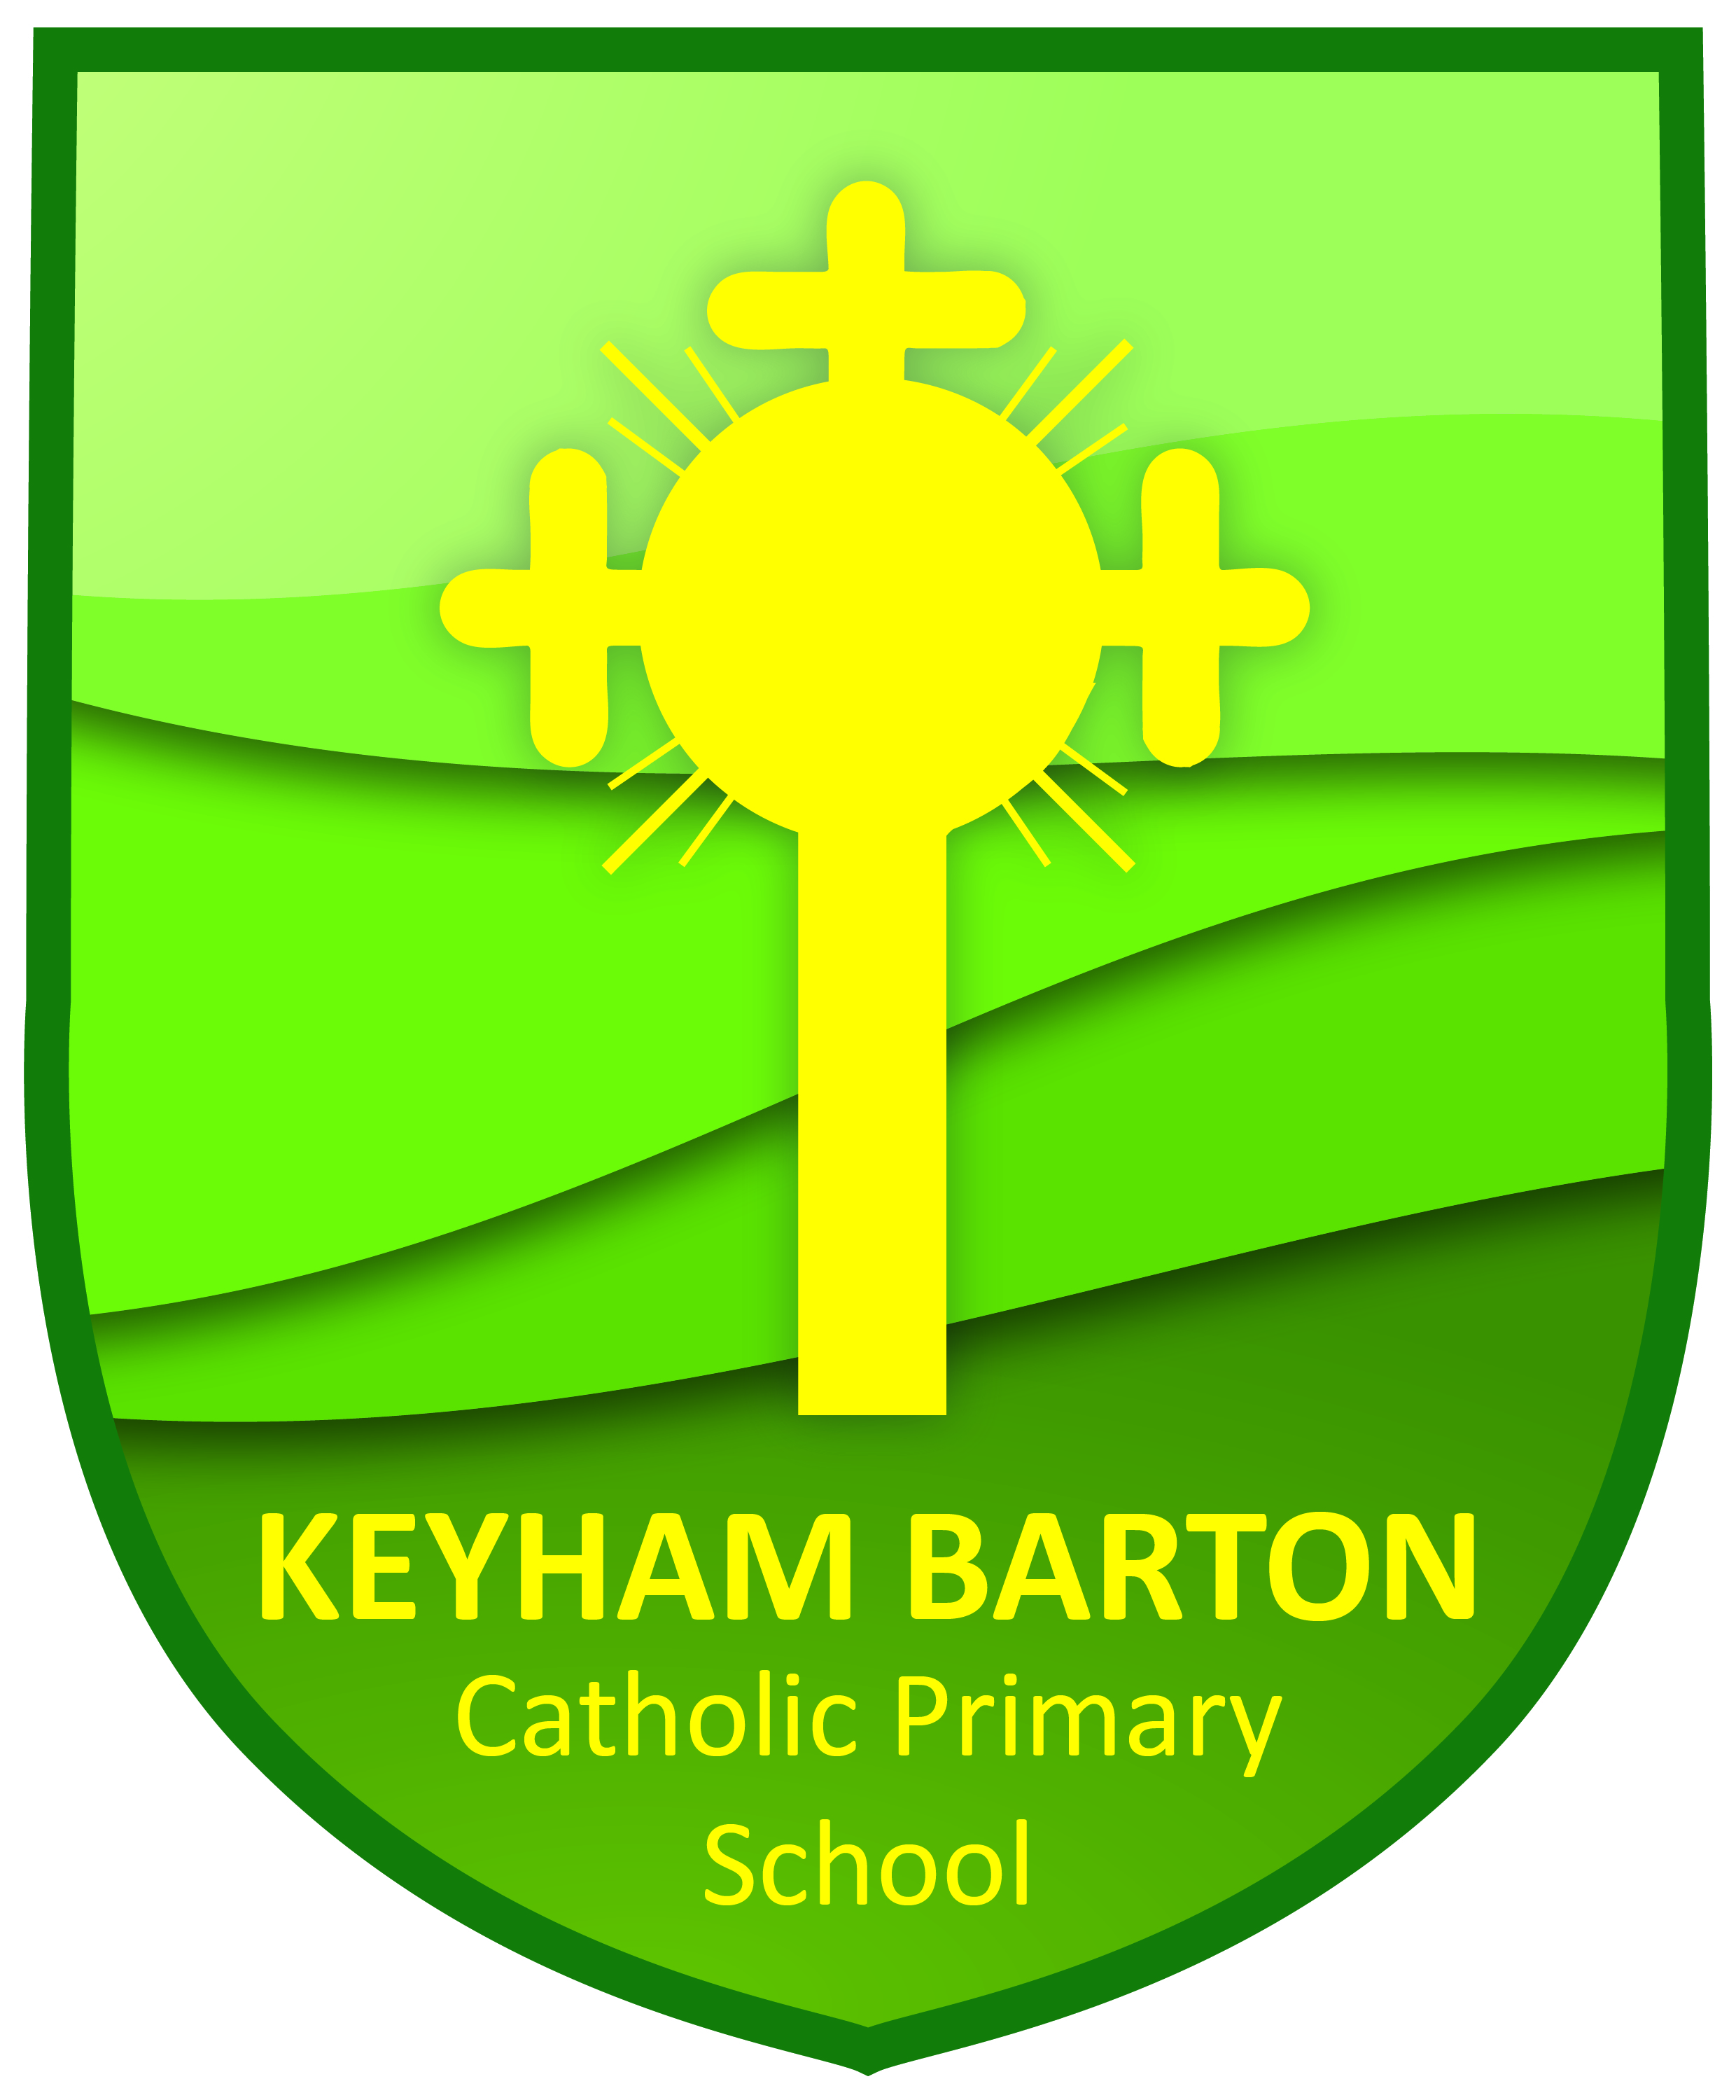

September 2019
A faith community, gathered together to learn,
with love and respect for each other.

‘The most powerful single moderator that enhances achievement is feedback’ John Hattie

‘...the impact of feedback is 124 times more cost effective than reducing class sizes’ Higgins/Sutton Trust Report

Introduction
This policy outlines the purpose, nature and management of marking at Keyham Barton Catholic Primary School. This policy reflects the consensus and opinion of the whole teaching staff, and has the support of the Governing body.

The Purpose of Marking
The main purpose of marking any piece of work is to give feedback, assess the depth of learning that has taken place, identify misconceptions to inform future planning providing both challenge and support in learning, raise self-esteem, foster independence and encourage children’s ownership of their own learning.

Quality feedback includes:
Written feedback
Verbal feedback
Live Marking
Self-Assessment
Peer Assessment

At Keyham Barton effective marking will:
- be manageable
- show consistency and continuity throughout the school
- be positive and show that the efforts of our learners are valued; raise self-esteem, motivate and reassure
- enable staff and children to have confidence in the belief that every pupil can improve
- relate to Learning Objectives and/or success criteria and so communicate clear expectations to the children
- correct misconceptions and identify ‘Next Steps’ for pupils
- promote review and reflection by teachers upon assessment data
- inform planning
- encourage children to be reflective and evaluate their own learning and behaviour by being involved in self-assessment and peer assessment
- cover a broad spectrum of responses to children’s work and operate on different levels appropriate to the child and the learning intention. It could be verbal, written, printed, peer or self.

Implementation
Written Feedback
- Written Feedback – Written feedback will be given in green pen. Children will self-mark or peer-assess in purple.
- Prioritise – Over the week ensure you have looked at each group in more depth. Mark one group a day.
- Printed Statements – these can be next steps, cloze sentences or challenge questions to further learning. Statements should be printed in green to indicate they are marking comments and responded to in purple.
- Post-Its – Post-Its can be used to evidence what children have said that shows understanding or what an adult has observed.
- Target Setting – Teachers, assessment and planning will inform gaps and next steps. Children will have ownership over these and be able to articulate what their next steps are and how they will get there.
Verbal Feedback
- Verbal Feedback – VF in books
- Spellings will be marked according to the focus of the piece of work, phonics/spelling patterns previously taught and the teachers’ expectations of each individual child. Children are encouraged to correct these with their purple editing pen. Teachers check spellings and feedback regularly to ensure the same mistake is not made continually without evidence of progress.
- Surgeries: Children are given opportunity during surgeries and conferencing to review learning and to correct errors using their purple editing pen.
- Margin Marking – indicate mistakes by a number in the margin for children to self-correct in a paragraph.
Live Marking
- Live marking – Switching your mindset from marking after the lesson to within the lesson – e.g. roving or with a Guided Group. Both T and T can do this.
- TA marking – TAs can rove or work with a group and mark work using the marking codes and correct misconceptions during the lesson.
- Yellow box marking – draw a yellow box around part of a piece of work and mark this part with a focus. Children to edit and redraft underneath focusing on improvement. Their response will show progress against the area identified for improvement.
- Marking Symbols - A common set of symbols will be used throughout the school, to indicate how children can improve their work. These symbols will be introduced progressively, appropriate to the age and understanding of the children.
- Find and Fix – tell children the number of errors to find in a piece of work and to find and self-correct in the lesson, either individually or in groups.
Peer Feedback
- Peer-Assessment – Children will have training around effective Peer Assessment and United Improvement, against the LO’s. children will be taught how to find 2 stars and a wish or WWW / EBI with a focus on the positive and not just picking up handwriting or spelling!
- United Improvement – In groups of 3 children share their learning and work cooperatively to improve and uplevel it.
Self-Assessment
- Self-Assessment - Children will have training around effective Self- Assessment using the LO’s and success criteria and knowledge of their own learning behaviours. Children will be encouraged to have ownership over their next steps and targets and will be able to articulate what it is they need to do to improve. Children can highlight work in green to show evidence linked to the LO and success criteria.
- Success Criteria – Success criteria will be clear and linked to the LO’s and the KEY OUTCOME for the learning, linked to whole class and individual targets. Children will be able to articulate the success criteria and self-assess or peer-assess against it. Keep the main thing the main thing and link to gap analysis.
- Traffic Lights – Ask children to leave a red, yellow or green dot on their work to indicate areas they have struggled with. Or children to self-assess and place books in green, amber or yellow pile or a check-in pile for surgery.
- Response to feedback – Children should be given an opportunity to respond to feedback in order to improve their work or further learning. This can be during a lesson or during directed target time.

Monitoring Impact and Progress
Learning Walks: During learning walks, pupils will be expected to discuss their feedback, what they are doing well and what targets they are working on. They will be able to confidently talk about their own progress and their next steps.
Planning: Planning will show opportunities for peer and self-assessment. Clear success criteria will support self-assessment. Annotations may show where AFL has take place.
Book Scrutiny: Books will show progress and marking codes will be in line with the marking policy. LO’s will indicate level of support given and success criteria. Children will have responded to marking in purple and to all yellow boxes. This will also evidence editing and improvement.
Progress: Strong progress will be evident across all books. Progress will also be tracked in data drops, PIRA and PUMA and tracking.

Conclusion
At the heart of children’s learning is the recognition that every child can improve and that it is the teachers’ job to diagnose the next learning steps and provide opportunities for the children to take them, whilst also acknowledging the power of peer assessment and challenge and how self assessment and challenge empowers children to own their learning. Structured, systematic analysis of pupil’s work and of the termly assessments will enable teachers to ensure progress is being made.

Recommend for Adoption: September 2019
Review Date: September 2021

Signed: ………………………………………………………………. Date:
(Chair of Governors)

Signed: ………………………………………………………………. Date:
(Head Teacher)
MARKING SYMBOLS

? GO BACK AND CHECK

Sp SPELLINGS (WRIGGLY LINES
DRAWN UNDERNEATH THE WORDS)

T2T TALK TO THE TEACHER

DJ Dojos AWARDED

S Supply – indicated in LO

I INDEPENDENT WORK – indicated in LO

T/TA T/TA Supported – indicated in LO, together with the level of support given

+ SURGERY (this may include notes for the
Teacher)

