Examples of what children should be able to do, in relation to each (boxed) Programme of Study statement
add and subtract numbers with up to 4 digits using the formal written methods of columnar addition and subtraction where appropriate
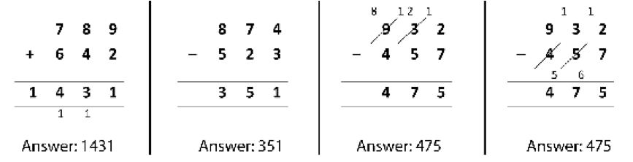

estimate and use inverse operations to check answers to a calculation
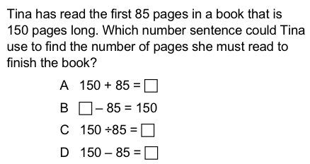

solve addition and subtraction two-step problems in contexts, deciding which operations and methods to use and why
Children should be able to carry out practical tasks such as that represented here in an Australian classroom.
Children were asked to individually run the class market stall. They were told they could use mental strategies or the whiteboard provided to assist them in their calculations. The customer (their teacher) would come to purchase some items. Each child was asked to solve a transaction problem involving a single item (calculating change – subtraction) and then a transaction involving two items (adding together values and then calculating change or two subsequent subtractions). They were also asked to explain their thinking and asked how to give the change in a different way (representing money values in various ways).
Children should be able to solve problems such as:
- I have read 134 of the 512 pages of my book. How many more pages must I read to reach the middle?
- There are 8 shelves of books. 6 of the shelves hold 25 books each. 2 of the shelves have 35 books each. How many books altogether are on the shelves?
- I think of a number, subtract 17, and divide by 6. The answer is 20. What was my number?
- You start to read a book on Thursday. On Friday you read 10 more pages than on Thursday. You reach page 60. How many pages did you read on Thursday?

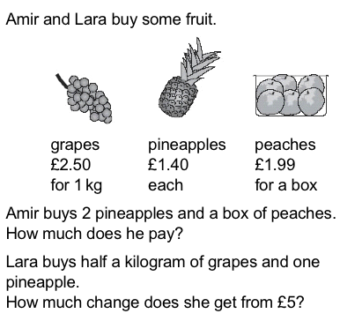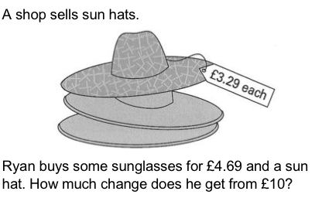

Non-Statutory Guidance
Pupils continue to practise both mental methods and columnar addition and subtraction with increasingly large numbers to aid fluency

