Examples of what children should be able to do, in relation to each (boxed) Programme of Study statement
measure, compare, add and subtract: lengths (m/cm/mm); mass (kg/g); volume/capacity (l/m)
Children should be able to:
Length: Show something that they think is just shorter/longer than a metre/centimetre/millimetre. They should be able to check whether they are right.
Mass: Say which object in the classroom is heavier than 100 g/kilogram/half-kilogram and know how to check if they are correct.
Read scales such as this:
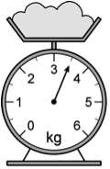
Capacity: Find a container that they think would hold one litre and check to find out if they were correct.
General: Say what each division on this scale is worth and explain how they worked this out.

measure the perimeter of simple 2-D shapes
Children should be able to:
Measure the sides of regular polygons in centimetres and millimetres and find their perimeters in centimetres and millimetres?

add and subtract amounts of money to give change, using both £ and p in practical contexts
Children should be able to:
Solve problems like this:
- Jake wants to buy a comic that costs £1. He saves 25p one week and 40p the next. How much more money does he need to buy the comic?
- Add these prices: £6.73, £9.10 and £7.00 to find the total. Find out how much they need to add to get £23?

tell and write the time from an analogue clock, including Roman numerals from I to XII, and 12-hour and 24-hour clocks How would this time appear on a 12-hour digital clock?
Children should be able to:
Read times like this in analogue and digital formats, including those with Roman numerals.
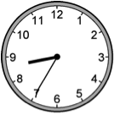
Solve problems such as: Ben’s clock says 7:50 when he gets up. Place the hands on this clock to show this time.

estimate and read time with increasing accuracy to the nearest minute, record and compare time in terms of seconds, minutes, hours and o’clock; use vocabulary such as a.m./p.m., morning, afternoon, noon and midnight
Children should be able to:
Solve problems such as:
- Kevin leaves home at quarter past 8 and arrives in school at 20 to 9. How long is his journey? How did you work this out?
- How long is it between the times shown on these two clocks? How did you work it out?(oral question)
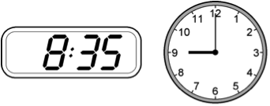

know the number of seconds in a minute and the number of days in each month, year and leap year
Children should be able to:
Solve problems such as: Milly has a 100 ml bottle of medicine. She takes one fifth of the medicine each day. How many days does she take the medicine for? How much medicine does she take each day? What calculation did you do to work this out?

compare durations of events, for example to calculate the time taken by particular events or tasks
Children should be able to:
Solve problems such as:
- Estimate how long your favourite TV programme lasts. Use a television guide to work out how close your estimation was.
- It takes 35 minutes to walk from home to school. I need to be there by 8.55 am. What time do I need to leave home?
- How much does it cost to hire a rowing boat for three hours?
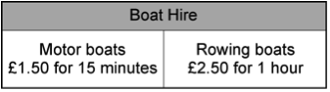
- Sasha pays £3.00 to hire a motor boat. She goes out at 3:20 pm. By what time must she return? Explain how you solved this problem. Could you have done it in a different way?
- Sally and Maria both went to the gym on Saturday. Sally was there from 2 pm until 3.30pm. Maria was there from 12.30 pm until 3.15 pm. Who spent the longer time at the gym? How much longer was she there than her friend?

Non-Statutory Guidance
Pupils continue to measure using the appropriate tools and units, progressing to using a wider range of measures, including comparing and using mixed units (e.g. 1kg and 200g) and simples equivalents of mixed units (e.g. 5m = 500cm).
The comparison of measures should also include simple scaling by integers (e.g. a given quantity or measure is twice as long or five times as high) and this connects to multiplication.
Pupils continue to become fluent in recognising the value of coins, by adding and subtracting amounts, including mixed units and giving change using manageable amounts. They record £ and p separately. The decimal recording of money is introduced formally in year 4.
Pupils use both analogue and digital 12-hour clocks and record their times. In this way they become fluent in and prepared for using digital 24-hour clocks in year 4.

