The Team
Teacher: Mrs Quick (every morning and Tues - Thurs pm) and Mrs Roberts (Mon and Fri pm)
Teaching Assistant: Mrs Prestidge (all week)

Our Curriculum
In Peace Class, we will be looking at a fun and exciting range of topics linking across all of our subjects. Our main areas of learning for this term are the Vikings, Dartmoor (which we will be visiting on 17th April) and light. Please see the attached topic map for a more detailed overview of our curriculum for the summer term. Year 4, you will be having 3 weeks of statutory swimming lessons in the second half term. More information will be sent out about this shortly.

Home Learning
Reading: You will be expected to read daily at home and bring your reading book and Home/School link book to school every day. You will then take your AR quiz in school with the expectation that you will reach your target number of points each half term. As this becomes an established part of your daily routine, we will then be able to concentrate more on developing comprehension skills in school. Mrs Whitting (our volunteer) hears each of you read twice a week, with some of you being heard more regularly by Mrs Prestidge too.
Spellings: You will continue to practise spellings daily in school and will add keywords to your personal spelling log as well as taking home your bookmark spellings to learn. Mrs Prestidge aims to test each of you twice a half term.
Maths Flex & Times Tables Rockstars: Please continue to practise and learn these vital number bonds at home so that they can be applied to our learning in school. We will build regular Times Tables Rockstars sessions into our classroom maths, which you’ll be able to practise at home as well! Year 4 children, you will be having a government test on times table facts in June, so it is important to build up your confidence with these vital facts at home as well as in school.
Home Learning Grid: As an optional extra, there will be a home learning grid sent home and uploaded to Dojo with activities from across the curriculum to choose from if you wish.

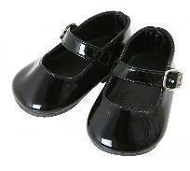
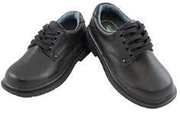
Peace Class Expectations and Reminders
In Key Stage 2, we are role models to the younger children with both our behaviour and our appearance. You need to make sure that you are wearing the correct uniform at all times. This means tucking your shirt in if you’re wearing a school tie and wearing black school shoes, not trainers. If you need to check the uniform rules, you can get this information from the office or school website.
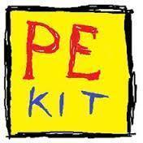
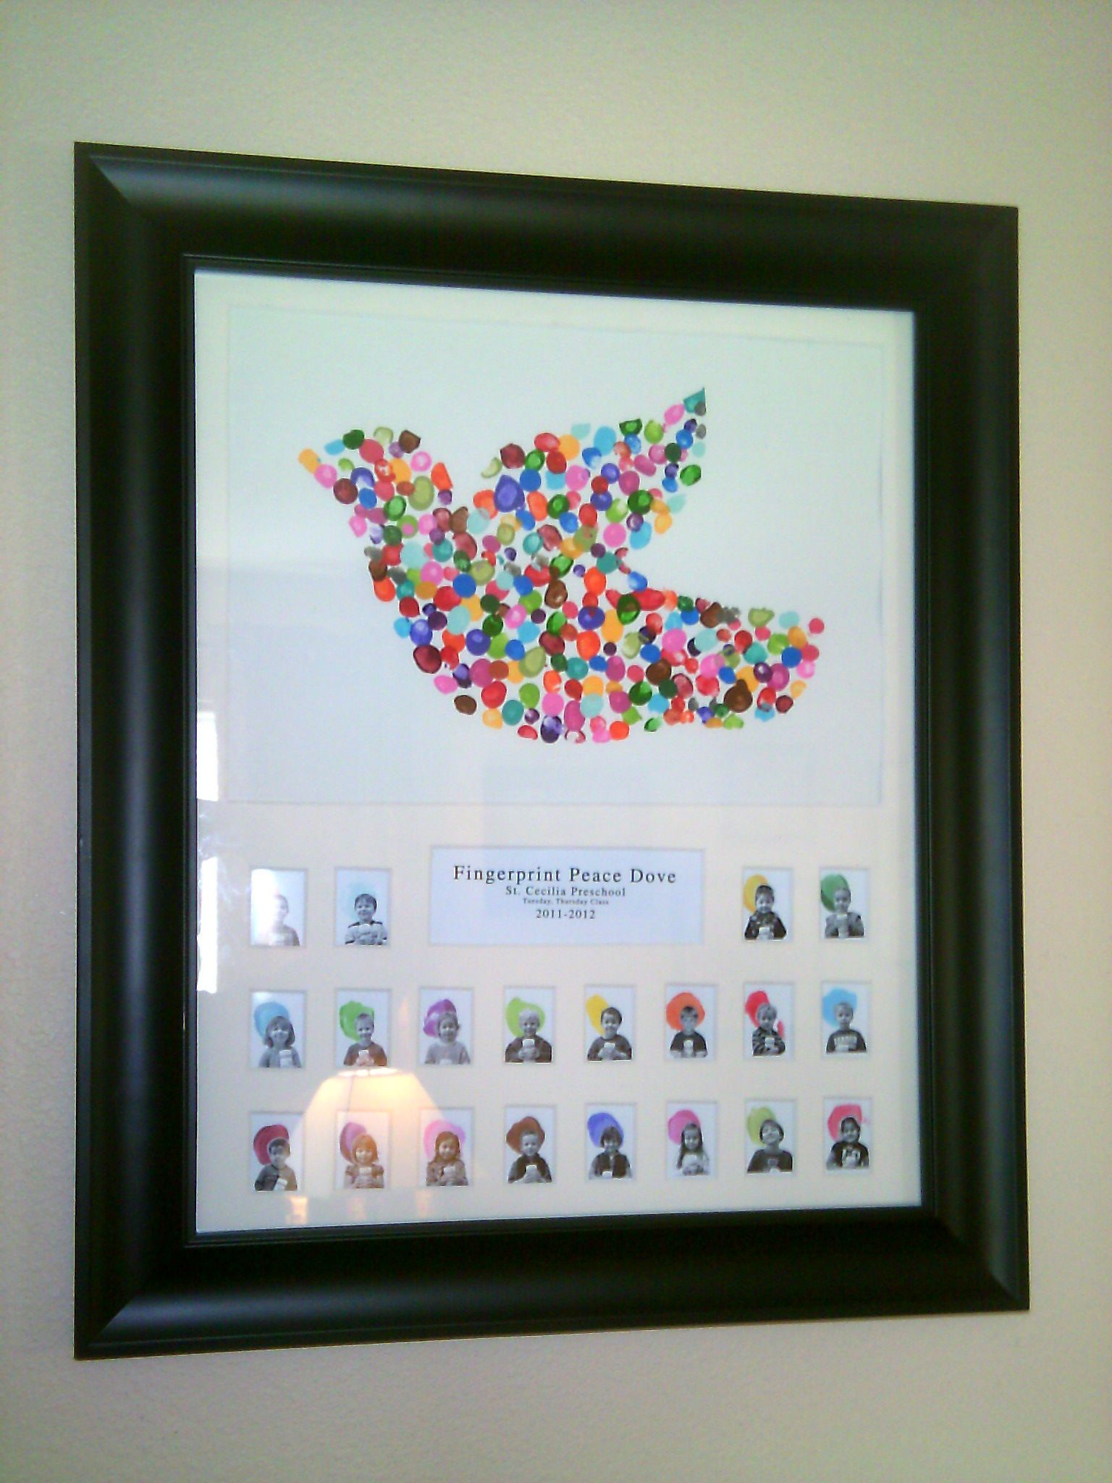
This year, we will continue with asking you to wear their PE kits all day on PE days. All of Peace Class will need to wear a PE kit to school on a Tuesday and Thursday. You can wear black leggings/joggers or shorts with your yellow PE top and school jumper. You will be allowed to wear your coats too for outside PE if it is particularly cold or wet, so please ensure one is brought into school daily.
You must not bring in any stationery or trading cards/toys into school from home due to the fallouts and upset this can cause. All equipment needed for the school day will be provided by us.
I am really excited about the next term in Peace Class. If parents have any queries or concerns, please contact the school office who will pass on any messages, or speak to me at the end of the school day.
Mrs Quick

