The Team
Teacher: Mrs Quick (every morning and Wed-Fri pm) and Miss Jones (Mon and Tues pm)
Teaching Assistants: Miss Jones (Mon - Thurs am) and Mrs Prestidge (all week)
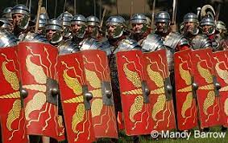
Our Curriculum
In Peace Class, we will be looking at a fun and exciting range of topics linking across all of our subjects. Our main areas of learning for this term are the Romans, the UK, and skeletons and muscles. If you are in Year 4, you will be participating in the mini police programme with the Year 4 children from Integrity each Thursday afternoon. Please see the attached topic map for a more detailed overview of our curriculum for the spring term.
Home Learning
Reading: You will be expected to read daily at home and bring your reading book and Home/School link book to school every day. You will then take your AR quiz in school with the expectation that you will reach your target number of points each half term. As this becomes an established part of your daily routine, we will then be able to concentrate more on developing comprehension skills in school.
Spellings: You will continue to practise spellings daily in school and will add keywords to your personal spelling log as well as taking home your bookmark spellings to learn.
Rapid Recall Challenge & Times Tables Rockstars: Please continue to practise and learn these vital number bonds at home so that they can be applied to our learning in school. We will build regular Times Tables Rockstars sessions into our classroom maths, which you’ll be able to practise at home as well! Year 4 children will be having a government test on times table facts in June, so it is important to build up your confidence with these vital facts from September.
Home Learning Grid: As an optional extra, there will be a home learning grid sent home and uploaded to Google Classroom with activities from across the curriculum to choose from if you wish.

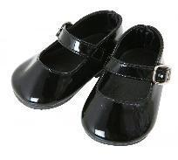
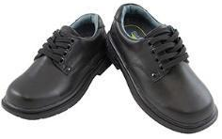
Peace Class Expectations and Reminders
In Key Stage 2, we are role models to the younger children with both our behaviour and our appearance. You need to make sure that you are wearing the correct uniform at all times. This means tucking your shirt in if you’re wearing a school tie and wearing black school shoes, not trainers. If you need to check the uniform rules, you can get this information from the office or school website.
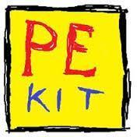
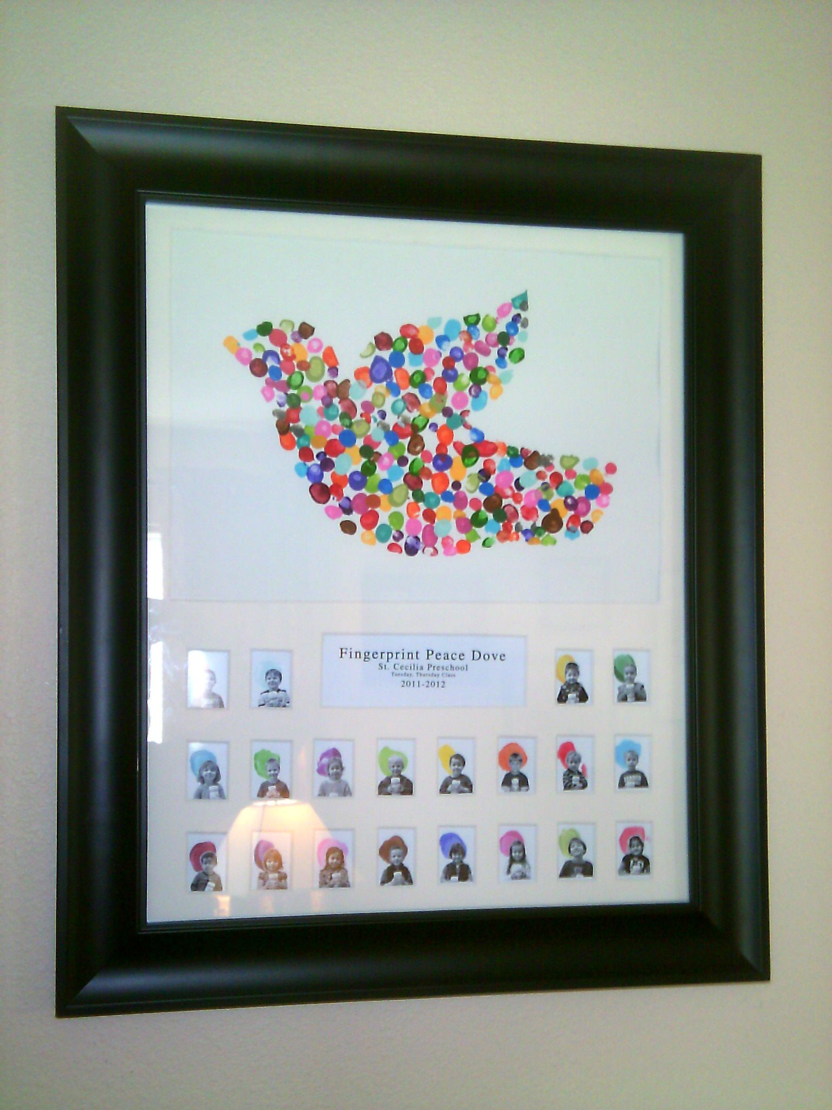
This year, we will continue with asking children to wear their PE kits all day on PE days rather than getting changed at school. All Peace Class children will need to wear PE kit to school on a Tuesday and Friday. Children can wear black leggings/joggers or shorts with their yellow PE top and school jumper. They will be allowed to wear their coats too for outside PE if it is particularly cold or wet, so please ensure one is brought into school daily.
Children must not bring in any stationery (or football/Pokemon cards!) from home. All equipment will be provided by the school.
I am really excited about our new term together in Peace Class. If you have any queries or concerns, please contact the school office who will be able to pass on any messages or speak to me at the end of the school day.
Yours sincerely,
Mrs Quick

