Examples of what children should be able to do, in relation to each (boxed) Programme of Study statement
interpret and construct simple pictograms, tally charts, block diagrams and simple tables
- Class 2 make a graph
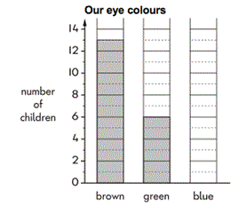
5 children have blue eyes. Show this on a graph. More children have brown eyes than green eyes.
How many more?

ask and answer simple questions by counting the number of objects in each category and sorting the categories by quantity
- Look at this pictogram
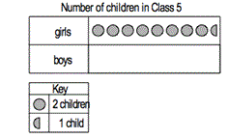
There are 12 boys in class 5.
Show this on a pictogram.
- A shop sold 10 ice lollies on Wednesday.
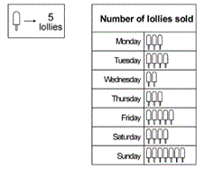
How many lollies were sold on Monday?
How many more lollies were sold on Tuesday than on Wednesday?

ask and answer questions about totalling and comparing categorical data
- Some children rolled toy cars down a slope
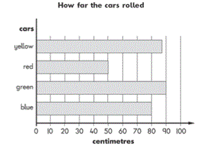
How far did the blue car roll?
How much further did the green car roll than the red car?
additional questions:
  - Which car rolled the furthest?
  - Make up a question about the red car and the yellow car.
- Jane made a tally chart
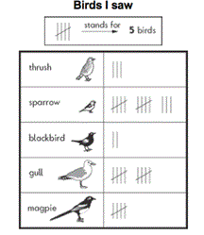
How many more gulls than blackbirds did she see?
Additional questions:
  - Make up a question comparing the numbers of sparrows and blackbirds that Jane saw?
  - How many fewer thrushes than magpies did she see:-
    - 12
    - 2
    - 10
    - 3
- Some children were asked to choose their favourite animal in the zoo.This table shows the results.
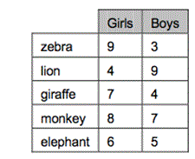
How many more girls than boys chose the giraffes?
How many more boys chose lions than elephants?
Which animal was chosen by the greatest number of children

Non-Statutory Guidance
Pupils record, interpret, collate, organise and compare information (e.g. using many-to-one correspondence with simple ratios 2, 5, 10).

