Examples of what children should be able to do, in relation to each (boxed) Programme of Study statement
identify, describe and represent the position of a shape following a reflection or translation, using the appropriate language, and know that the shape has not changed
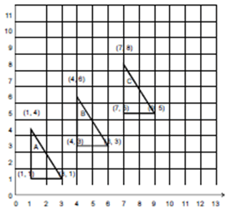
Write the co-ordinates of the next triangle in the sequence.

Non-Statutory Guidance
Pupils recognise and use reflection and translation in a variety of diagrams, including continuing to use a 2-D grid and coordinates in the first quadrant. Reflection should be in lines that are parallel to the axes.

