Examples of what children should be able to do, in relation to each (boxed) Programme of Study statement
describe positions on a 2-D grid as coordinates in the first quadrant
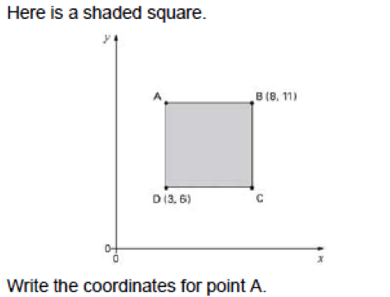

describe movements between positions as translations of a given unit to the left/right and up/down
I can describe where a shape will be after translation | This triangle is translated two squares to the left and one square down.  Give the coordinates of its vertices in the new position. | 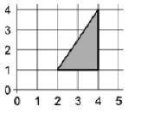

plot specified points and draw sides to complete a given polygon
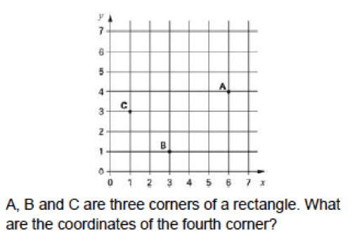

Non-Statutory Guidance
Pupils draw a pair of axes in one quadrant, with equal scales and integer labels. They read, write and use pairs of coordinates, for example (2, 5), including using coordinate-plotting ICT tools.

